Create an instance for jenkins

Installed and started jenkins on the terminal

Opened Jenkins

Space Problem

Increased tmp space

Problem Solved

Added Webhooks

Downloaded plugins – deplot to container, maven intergration and github integratrion

Insalled Maven in terminal

Copied path and registered in jenkins

Created a project

Created a tomcat instance

Installed and set up Tomcat in terminal

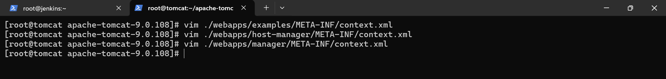

Set Credentials in jenkins

Set Tomcat in Jenkins

Built

Created docker

Set up docker

Premitted root login and password authentication in docker as well as jenkins

Generated ssh keys in docker

Sent ssh keys to eah other

Install publish over ssh plugin in jenkins.

Registered jenkins and docker node in jenkins system.

Created an user and attached administrator access policy and generated access keys

Configured aws in docker node

In project, added jenkins in post build actions and sending all files in docker via automation

It’s done

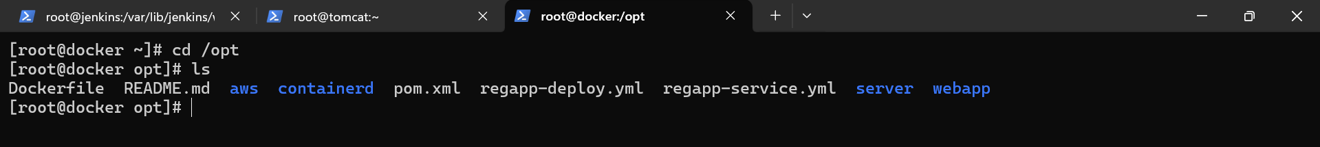

Now I am creating a ecr via automation through jenkins

A new eks instance created and set up in terminal

Configured aws in eks node

Installed EKS Tool

Installed kubectl

Generated ssh key and connected it eith docker node



Created a cluster

Created a nodegroup

Permitted root login and password authentication

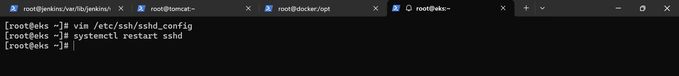

Sent deployment and service file to eks node.



Copied the ecr image’s url

Pasted it in deployment

Registered eks in jenkins

Added eks in post build actions

Build is succe ssful.

Ran kubectl get svc - copied link and pasted in browser with port 8080

